How to add a logo to the top of an Alma Analytics report | 

To add a logo to the top of an Alma Analytic report, follow these steps:

We have this logo:



And we want to add it to the top of this report with the title:

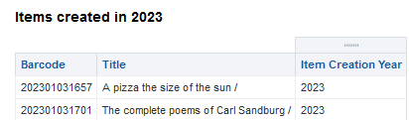

ONE
While focused on the Institution Folder Create a new folder and name it Images:

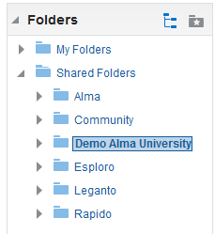

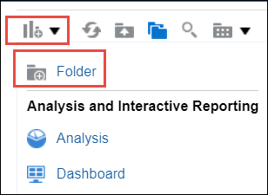

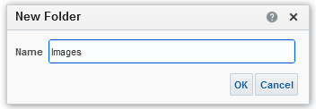

TWO
Select the Images folder and select Upload:

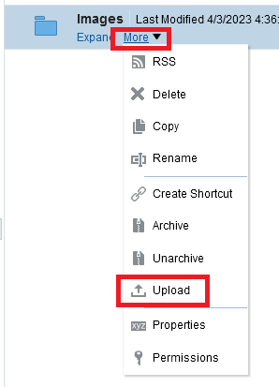

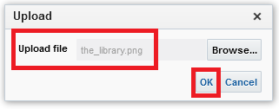
THREE
From the uploaded image, select More > Properties:

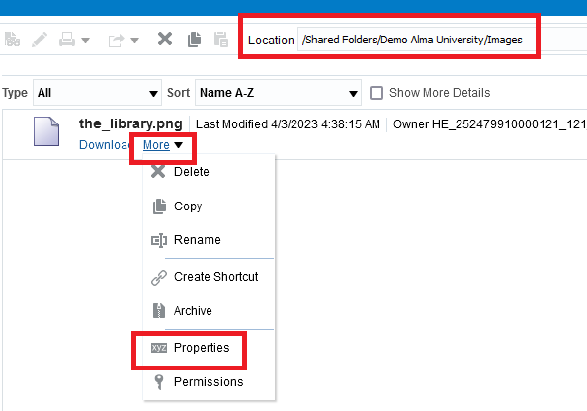

FOUR
Copy the name and location of the image because we will need it later:

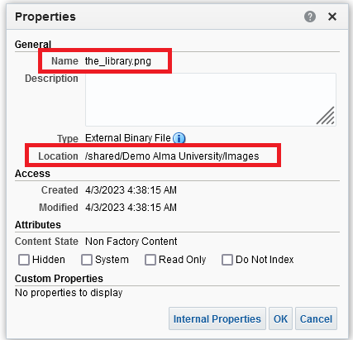

Name the_library.png
Location /shared/Demo Alma University/Images

FIVE
Create or edit an analytics report to which you want to add the image and select the edit icon (the pencil) of the title:

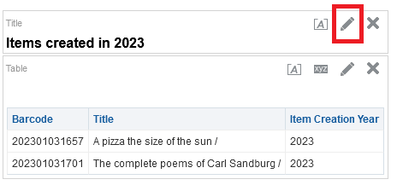

SIX
Select the Logo checkbox and select the Select Image button:

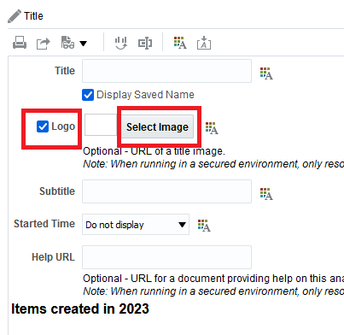

SEVEN
In the Custom Image box, enter the name and location of the image in the format: cmap:Location/Name
For example, if this is our location and name

Name the_library.png
Location /shared/Demo Alma University/Images

Then this is what we will add:

cmap:/shared/Demo Alma University/Images/the_library.png

Select OK

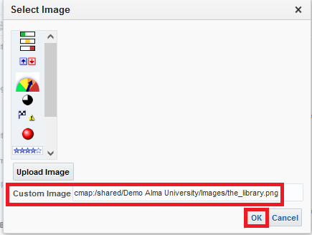

EIGHT
Select Done and save the report.

The image is added to the report.
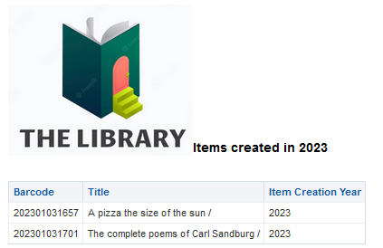

NINE
You could also put the image in a another title by adding another title and not including the title of the report in the new title so that it will only have the image:

We have this:

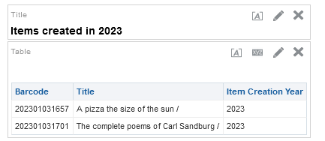

We add another title:

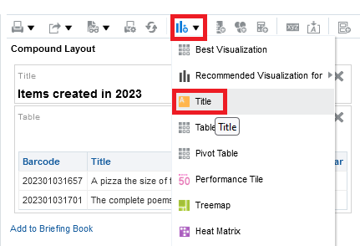

We move the new title to the top

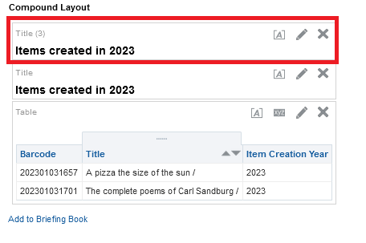

We edit the new title

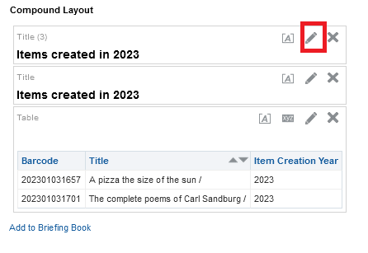

We uncheck the “Display saved name”

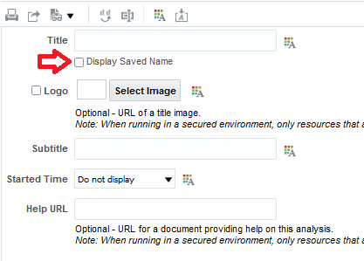

Then we add the logo as we prevoiously addded it, and the report will appear like this:

